# CS 255 System Design Document Template

This template lays out all the different sections that you need to complete for Project Two. Each section has guidance to prompt your thinking. You will need to continually reference the interview transcript as you work to make sure that you are addressing your client’s needs. There is no required length for the final document. Instead the goal is to complete each section based on what your client’s needs are. Remove this note when you are finished, and replace all bracketed text with the relevant information.

## UML Diagrams

### UML Use Case Diagram

### UML Activity Diagrams

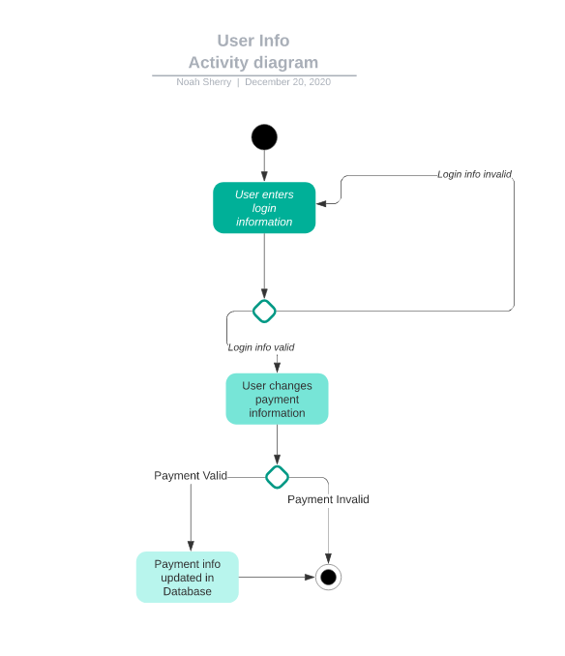

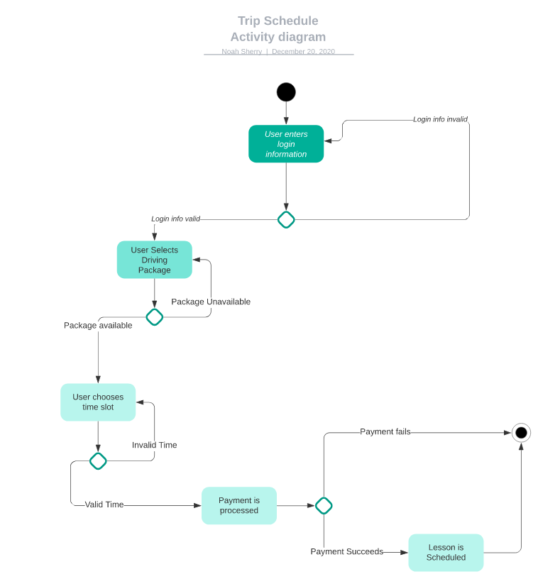

### UML Sequence Diagram

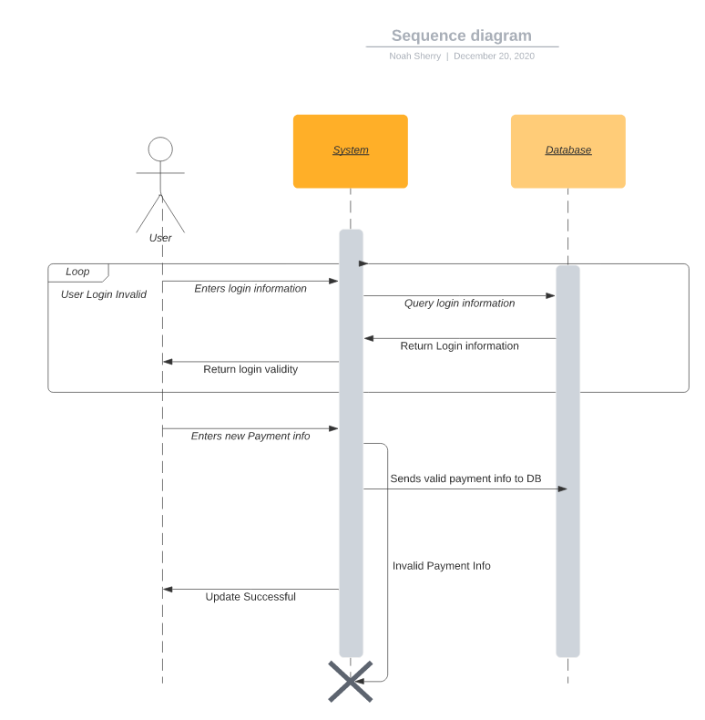

## Technical Requirements

Based on the information given in your statement, it appears that the system you are referring to requires a web-hosted server in the cloud, which will serve as the application server to handle user requests and business logic. The system will also need access to a high-availability database server, which can be hosted in the cloud or on-premises, to store and retrieve data.

In addition, the system requires integration with a payment processing service such as Stripe or Paypal, which will handle transactions securely and reliably. This integration will likely involve using APIs provided by the payment processing service to communicate with their platform and to initiate and process payments.

Overall, the system described will require a combination of web hosting, database hosting, and payment processing services to function effectively and provide a reliable and secure user experience.